1-WebSocket
# Source: AI Source: Provided by: [Data Path: Persons Table -> ID Column: 1, Name_En Column: Motasem Essam] -> From: [ChatGPT] on [1/18/2026]
WebSocket is a communication protocol that provides full-duplex (two-way), persistent communication between a client (usually a web browser) and a server over a single TCP connection.
🔄 Unlike HTTP, which is request-response based, WebSocket allows real-time, two-way communication — like a live chat, game, or stock ticker.

🔧 How WebSocket Works
# Source: AI Source: Provided by: [Data Path: Persons Table -> ID Column: 1, Name_En Column: Motasem Essam] -> From: [ChatGPT] on [1/18/2026]
- The browser makes a regular HTTP request with a special Upgrade header.
- The server agrees and "upgrades" the connection from HTTP to WebSocket.
- A persistent TCP connection is kept open.
- Both client and server can now send messages anytime, without waiting for requests.

🔁 HTTP vs WebSocket
# Source: AI Source: Provided by: [Data Path: Persons Table -> ID Column: 1, Name_En Column: Motasem Essam] -> From: [ChatGPT] on [1/18/2026]

Feature | HTTP | WebSocket
Type | Request-response | Full-duplex (two-way)
Connection | Closes after each request | Stays open
Overhead | High (headers every time) | Low (after initial handshake)
Speed | Slower for real-time updates | Very fast
Use Case | Web pages, APIs | Chat, gaming, real-time data

🧰 Example Use Cases
# Source: AI Source: Provided by: [Data Path: Persons Table -> ID Column: 1, Name_En Column: Motasem Essam] -> From: [ChatGPT] on [1/18/2026]
- 💬 Live chat apps (e.g., WhatsApp Web)
- 🎮 Online multiplayer games
- 📈 Real-time stock price updates
- 🛎️ Notification systems
- 🗺️ Live location tracking

🔐 Security
# Source: AI Source: Provided by: [Data Path: Persons Table -> ID Column: 1, Name_En Column: Motasem Essam] -> From: [ChatGPT] on [1/18/2026]
- Secure WebSockets use the wss:// protocol (WebSocket over TLS), like wss://example.com
- Similar to https:// for HTTP

🧪 Code Example (JavaScript in a Browser)
# Source: AI Source: Provided by: [Data Path: Persons Table -> ID Column: 1, Name_En Column: Motasem Essam] -> From: [ChatGPT] on [1/18/2026]
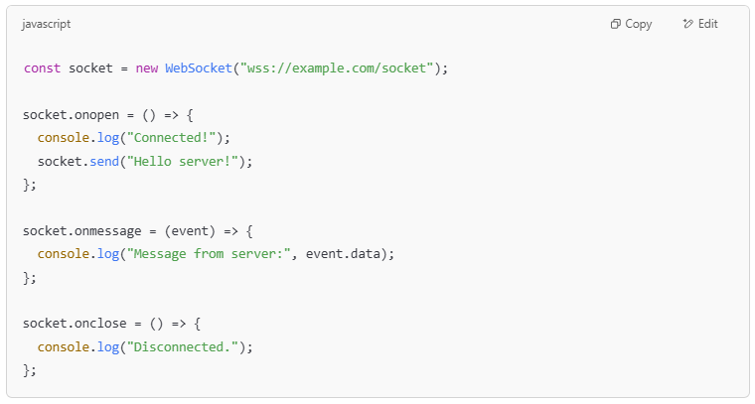
const socket = new WebSocket("wss://example.com/socket");

socket.onopen = () => {
console.log("Connected!");
socket.send("Hello server!");
};

socket.onmessage = (event) => {
console.log("Message from server:", event.data);
};

socket.onclose = () => {
console.log("Disconnected.");
};

WebSocket vs Socket

🔌 Socket (General Term)
# Source: AI Source: Provided by: [Data Path: Persons Table -> ID Column: 1, Name_En Column: Motasem Essam] -> From: [ChatGPT] on [1/18/2026]
A socket is a low-level network communication endpoint used to send and receive data between two machines over a network.
- It can use TCP (stream-based, reliable) or UDP (faster, but no guarantees).
- Used in many types of applications (FTP, email, SSH, HTTP, etc.).
- Typically built using programming libraries (e.g., Python's socket, Java's Socket class).
➡️ Think of it as the underlying plumbing for network communication.

🌐 WebSocket
# Source: AI Source: Provided by: [Data Path: Persons Table -> ID Column: 1, Name_En Column: Motasem Essam] -> From: [ChatGPT] on [1/18/2026]
WebSocket is a specific protocol built on top of TCP sockets for full-duplex communication between a web browser and a server.
- Designed for web applications
- Allows two-way communication without reloading the page
- Keeps a persistent connection open
- Begins with an HTTP handshake, then "upgrades" to WebSocket
➡️ Think of it as a high-level socket for the web — more specific and browser-friendly.

🔁 Key Differences
# Source: AI Source: Provided by: [Data Path: Persons Table -> ID Column: 1, Name_En Column: Motasem Essam] -> From: [ChatGPT] on [1/18/2026]

Feature | Socket | WebSocket
Level | Low-level API | High-level, browser-compatible
Protocol | TCP/UDP | WebSocket protocol (RFC 6455)
Use Case | Any kind of network communication | Primarily web apps needing real-time updates
Initial Connection | Direct TCP | Starts as HTTP, upgrades to WebSocket
Language Support | All languages | Mostly used in web technologies (JS, Node.js, etc.)

✅ Summary
# Source: AI Source: Provided by: [Data Path: Persons Table -> ID Column: 1, Name_En Column: Motasem Essam] -> From: [ChatGPT] on [1/18/2026]
All WebSockets use sockets, but not all sockets are WebSockets.
Use WebSocket when building real-time web apps (e.g., chat, live sports).
Use raw sockets when you need custom protocols, lower-level control, or non-browser-based networking.

✅ Summary
# Source: AI Source: Provided by: [Data Path: Persons Table -> ID Column: 1, Name_En Column: Motasem Essam] -> From: [ChatGPT] on [1/18/2026]
WebSocket = Real-time, two-way web communication
🧠 Built on top of TCP via HTTP
🔄 Supports push + pull messages
🚀 Ideal for real-time web apps
🔐 Use wss:// for secure communication

